DEEP LEARNING ASSIGNMENT 1:

**KARUNYA S**

**COMPUTER SCIENCE AND ENGINEERING**

#### Problem description:

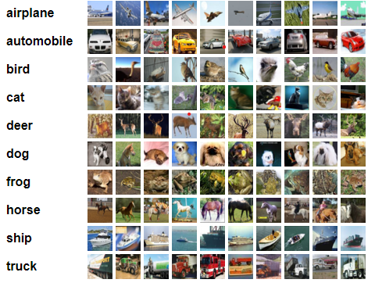

Input:32 x 32 coloured image datasets

Output: classification of images within 10 classes.

Sample data: The CIFAR-10 dataset consists of 50,000 training images and 10,000 test images.

## 

## 

#### Key Terminologies:

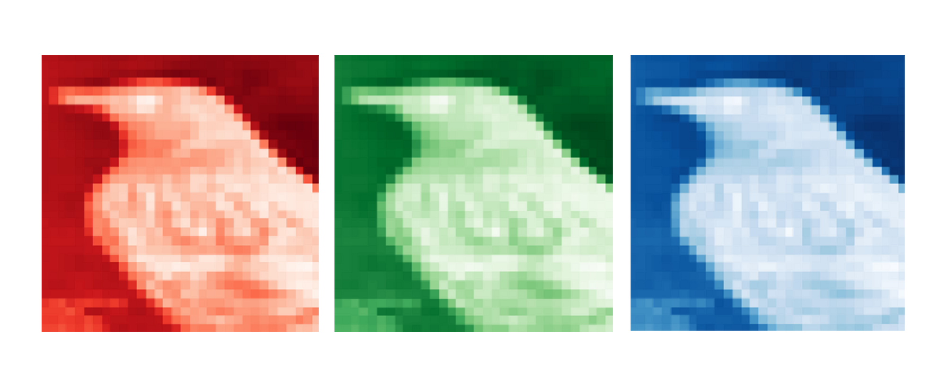

1. Neural Network: Neural networks are the method that teaches the computer to process the data like human brains. In the dataset of CIFAR-10 each image is stored as a flattened array and we will be using CNN. Each image is stored as flattened array of width*height*channels. Here channels are referred to as color spaces of images (red, green,blue).
2. Neuron: Neurons are the collection of software modules or nodes that work together to solve a problem.
3. Layer: A neural network has interconnected artificial neurons in three layers. They are Input Layer, Hidden Layer, Output Layer.
4. Input Layer: In the input layer the input nodes process the data , analyze or categorize it and pass it to the next hidden layer. Here the input layer with 32*32*3 inputs will feed the array images as inputs.
5. Hidden Layer: Here we will be training the basic neural network with one hidden layer and these will analyze the flattened array of the images that are fed as inputs from the input layer and pass to the next layer.
6. Output Layer: This layer will give the final result of all the data processed with 10 nodes.
7. Convolutional Layer: Before learning the term convolutional layer we have to know about convolutions.Convolutions are the hidden layers in CNN perform functions.This convolution layer will apply a convolutional operation to the input, passing the result to the next layer.
8. Convolutional Neural Network: For image classification tasks, CNN is best suited neural network. The convolutions in the CNN extract and process each array of images from the hidden layers.
9. Recurrent Neural Network: RNN is the process that converts sequential data input into a specific sequential data output.CIFAR-10 can be implemented using CNN with 90% accuracy rate.
10. Activation Function: It determines the output from the input. It decides whether a neuron should be activated or not by calculating the weighted sum and further adding bias to it. In CIFAR-10 we will be using ReLU and Softmax functions.
11. ReLU: Rectified Linear Unit introduces non-linearity in the model. Without non-linearity a neural network behaves like a linear regression model. In this case the input layer uses ReLU function along with the graph is given here. This function will always have a straight ReLU bent with x & y axis coordinates.
12. Sigmoid: The sigmoid function is used as the activation for the output layer of binary classifications. Here this function is not used.
13. Tanh: It is similar to sigmoid function but the only difference is it uses a hidden layer for activation instead of output layer.
14. Softmax: The softmax activation function transforms the raw outputs of the neural network into possibilities of vectors. In CIFAR-10 the output is a prediction vector with probability for each label. The output layer with the 10 class nodes for classification uses this activation function to give the probabilities for the different classes.
15. Forward Propagation: The process where the output of the previous layer will be passed to the next layer of the neural network in the forward direction and the cycle is repeated until the end of the neural network. In this process the data is fed forward through the network after applying weights and an activation function. Depending upon the type of problem the output layer outputs the number of output nodes.Here the problem type is classification of images so the output from the neural network will have one node per class which will go through the softmax function to obtain the final prediction.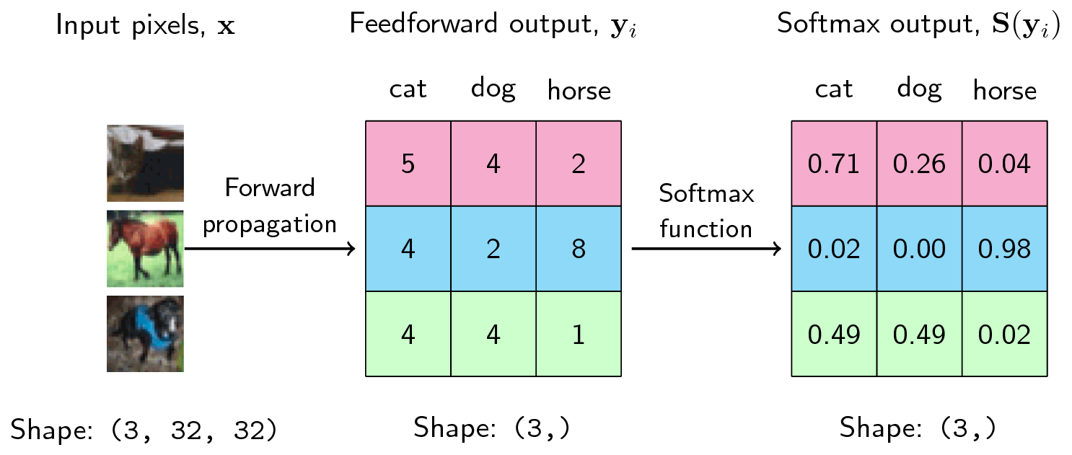
16. Backpropagation: The process where the output of the previous layer will be passed to the next layer of the neural network in many different paths. Among the different paths we use a feedback loop to identify the correct path which correctly maps the input node to the output node.
17. Loss function: Loss function is a method of evaluating how well an algorithm is modeling the dataset. In order to solve this problem the cross entropy loss is defined by restricting each label value within 1 by subtracting its maximum value.
18. Cost Function: It is a measure of the error between the predicted output and the actual output.The cost is calculated using the formula C = 1/2 (predicted – actual) ^ 2.
19. Gradient Descent: It is an optimization algorithm used in neural networks. Depending on the amount of data we choose stochastic gradient descent (SGD) to solve out CIFAR-10. It performs parameter update for each training image x(i) and its label y(i).
20. Learning Rate: LR determines how far the neural network weights changes while minimizing the loss function and there is no fixed learning rate for CIFAR-10 dataset.
21. Batch size: There is no definitive batch size for this dataset; we can use the common batch size of 32-256.
22. Epoch: An epoch represents one complete pass through the entire training data. The optimal number of epochs depends on the model complexity and the learning rate. The g range lies between 20 - 200 epochs for the CIFAR-10 dataset.
23. Overfitting: Occurs when the model learns the training data too well and performs poorly on unseen data.
24. Underfitting: Happens when the model is too simple to capture the underlying patterns in the data.
25. Training Set: The CIFAR-10 training set consists of 50,000 color images. These images are divided into 10 classes, with 5,000 images per class.
26. Validation Set: It is used to monitor the model's performance during training and adjust hyperparameters and for CIFAR-10 there is no specific validation set.
27. Test set: The CIFAR-10 test set contains 10,000 images.
28. Cross-Validation: It is a technique used to evaluate a model's performance on unseen data. As we don’t have a specific validation set we will be creating one by splitting the training set into *k* folds and iterate each fold to train and evaluate a model. This type of cross validation is called k-fold cross-validation.
29. Hyperparameters: Using CNN, the common hyperparameters used are number of convolutional layers, learning rate, dropout rate, fully connected layers size, etc.
30. Model Parameter: Weights and Biases are the two model parameters used in CIFAR-10. Weights represent the strength of connections between the neurons whereas biases are added to the output of neurons to adjust the activation.
31. Regularization: It is used to prevent or reduce the overfitting and make the neural network more generalized. We can use either L1 and L2 regularization or dropout methods.
32. Dropout: Dropout is applied after the hidden layer to help prevent overfitting.
33. Weight Initialization: It determines the starting point for the optimization process and can significantly impact the overall performance of the model.It can be done by assigning random values to weights in CIFAR-10 dataset.
34. Normalization: Normalization is a data pre-processing tool used to bring the numerical data to a common scale without distorting its shape.
35. Standardization: For CIFAR-10, standardization is often preferred as it's a common practice for image data. This involves converting pixel values (typically in the range 0-255) to a standard normal distribution.